Good morning,

Thank you for pointing our attention to the Census table with the disaggregated language data! We’ve updated those figures in the SCA draft, which is attached here. You can see Figures 11-13 for reference, but we’ve added the updated language and figures below as well:

Of the alternative language options, Spanish language materials should clearly be prioritized, as more than half of residents along the corridor speak Spanish (figure 11). While these residents may also speak English, a clear majority of the corridor has some level of Spanish proficiency. Meanwhile, just over 13% of residents speak Korean. Another 2% speak Chinese, and 5% speak other languages.

FIGURE 10
English Speaking Ability in the Pico Boulevard Corridor
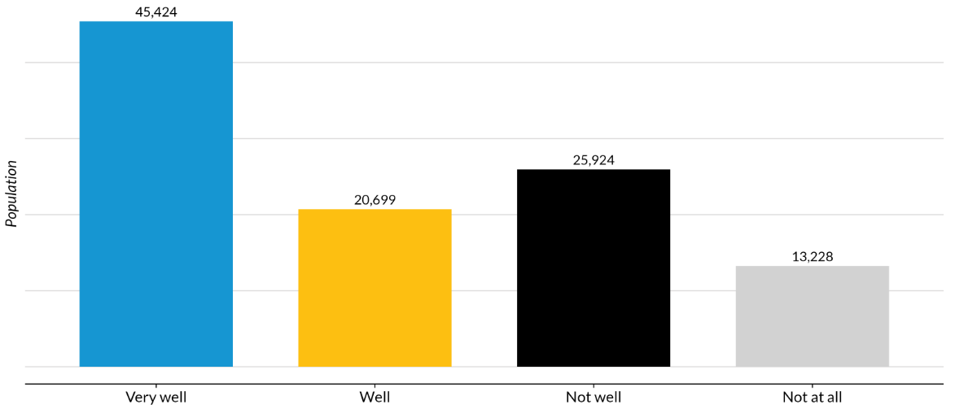
Source: Authors’ analysis of 2019-2023 American Community Survey data table B16004, ’Age by Language Spoken at Home by Ability to Speak English for the Population 5 Years and Over’.

FIGURE 11
Other Languages Spoken in the Pico Boulevard Corridor
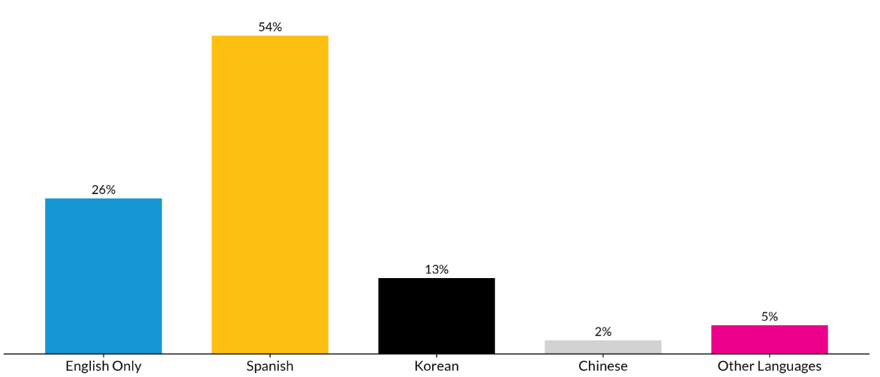
Source: Authors’ analysis of 2019-2023 American Community Survey data table C16001, ’Language Spoken at Home for the Population 4 Years and Over’.

When mapping the location of households where other languages are spoken, there are clear concentrations by language. In almost every tract in the Pico corridor, at least one fifth of households are Spanish-speaking (figure 12). Yet tracts in the eastern portion of the corridor have significantly higher concentrations of Spanish speakers than those in the western portion. Meanwhile, there is no one census tract where more than 50 percent of households speak Korean (figure 13), but there are three in the western portion of the corridor where more than 40 percent of households do.

Figure 12
Spanish-Speaking Population by Census Tract
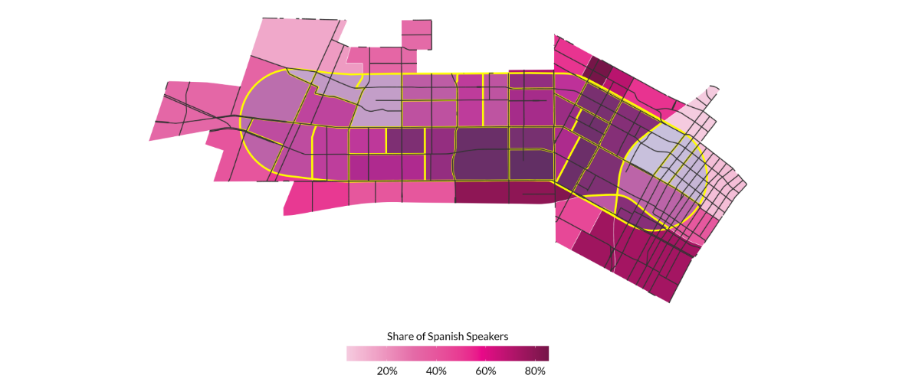
Source: Authors’ analysis of 2019-2023 American Community Survey data table C16001,’Language Spoken at Home for the Population 4 Years and Over’.
Notes: Percentage is based off total population in each census tract.

Figure 13
Korean-Speaking Population by Census Tract
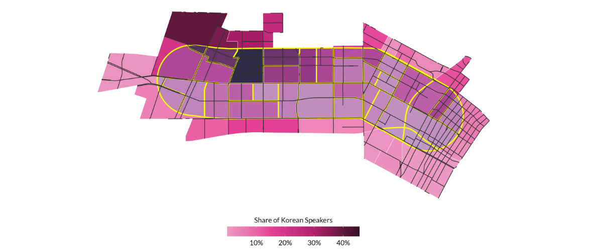
Source: Authors’ analysis of 2019-2023 American Community Survey data table C16001, ’Language Spoken at Home for the Population 4 Years and Over’.
Notes: Percentage is based off total population in each census tract.

